Step by Step Guideline to Submit the Case for MKT 344

Case Title: Help Deligram to Understand Their Customers Mindset! / Embrace the Change- The New Way of Online Delivery in Bangladesh | Deligram

Security Code for this case: mbt_mkt344
You need to go to Ideavan.net to participate in solving the assigned case.

Step 01: Sign Up
You need to sign-up will all the details required to participate. Once you complete the sign-up process through e-mail verification, you need to log-in to your account to land on the ‘Academia Page’- where you will find all the cases.
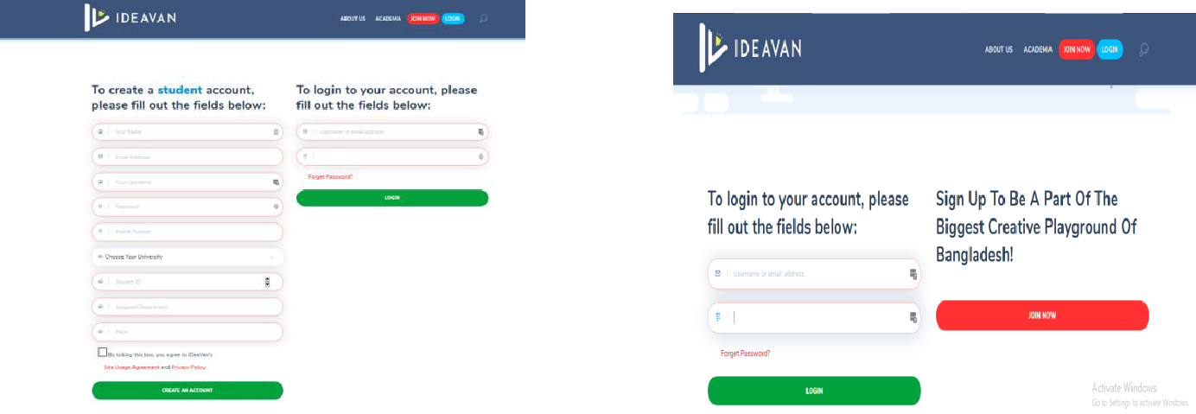

Log in here Using username and password
Sign Up Here

Step 02: Joining The Contest
Once you log in, you will land on the Academia page where you will find all the cases. Select the assigned case for your group by your faculty based on your course (In this case: Mgt489). Choose the case with your faculty initial and course initial. Once you find the assigned case, click to reach the summary page.
N.B. You must pay attention to the case title and the course title among all the cases there to find your own case.

For Instance if you are given the case with this title then Choose the Case Study for your Mkt 344 Case.

After reaching on the ‘Case Summary Page”- you will see the summary or a half-done case to get an idea about your assigned case. Once you have a good read of the summary, please put the course code (For your MKT344 course the code is: mbt_mkt344) provided to you by your faculty and click on Join Contest to land on the “Brief Case Page”
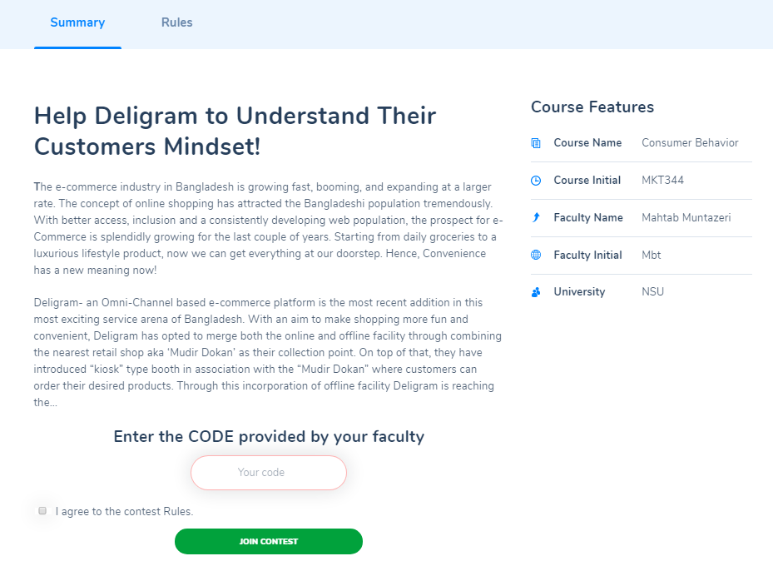
Put The Code Here and Click Join Contest
Once you reach at the Brief Case Page, have a good read of the whole case and pay full attention to the deadline (in the beginning) and the tasks (in the end of the case) that are required to solve the case. Once you have read the case carefully and ready to submit the solution, click on submission and you will be redirected to the submission scroller in the beginning. Once you click the submission on the top bar, you will be directed to the Submission Page.
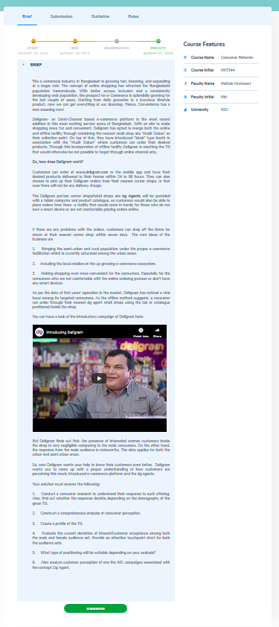
Click This Submission Button once you are ready to submit

Step 03: Submission
Once you click submission, you will land on the “Submission” page. The first task you have is to fill up the Group Name/Number (if you have any), Section (Must) and Add the team details as needed (must) except you as you have already logged in.

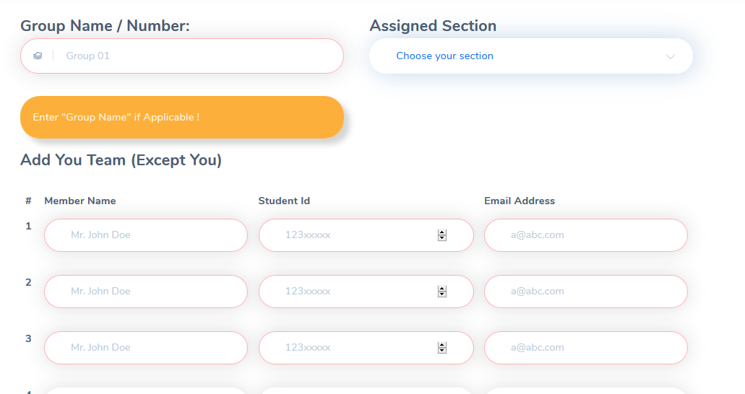
Must Fill Up
Must Fill Up
After adding the team, scroll down and answer all the questions. Read the questions properly and follow the instruction. E.g. The word limits.
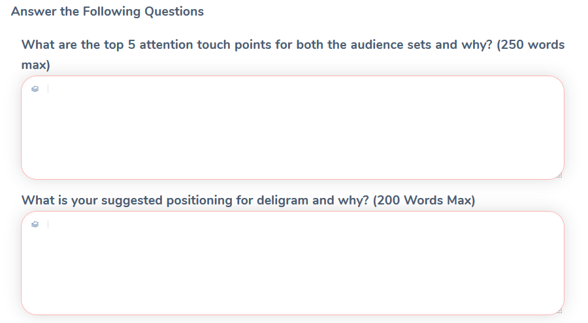
Once you are done with answering the questions given inside the submission panel, please submit your final report and presentation slide through the assigned section below in the same submission panel.
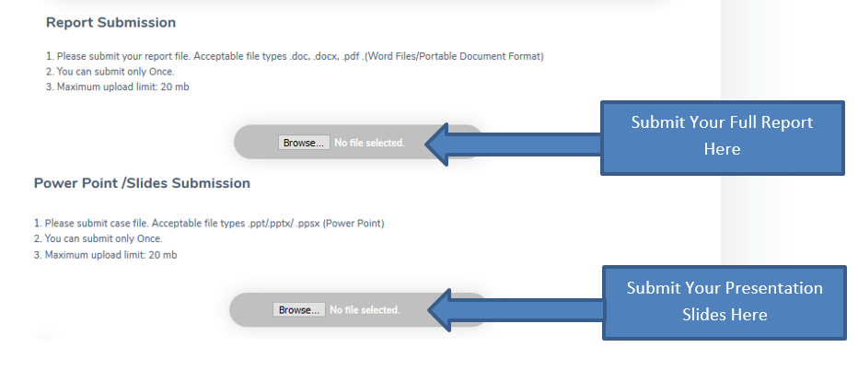
You must submit the full solution report as a regular report with proper name, id and faculty credentials in the end and also submit the power point slides of the solved case.
Click Submit Query once you are ready to submit the whole solution
Things to remember:
- You must have a look at the guidelines and rules of the contest before submitting.

- Check your spam/junk folder if you don’t receive the verification mail by 15 minutes.

- You can only submit once.

- You can’t submit any solution after the deadline.

If you have any queries or confusion or any problems regarding the log-in process/submission, feel free to mail us at ideavan.bd@gmail.com
Make sure you have a proper subject line of the mail. For example: The proper subject line for a group that is facing log in issue would be like below:
Group X_LogIn_Mkt460_Mbt_Section7

Good Luck!

